**SUMMER TRAINING REPORT**

**PYTHON PROGRAMMING ON THE PROJECT**

**SCIENTIFIC CALCULATOR**

Submitted in partial fulfillment of the

Requirements for the award of

**Degree of Bachelor of Technology in**

**Electronics & Communication Engineering**



**Submitted By:**

**Name: Ashish Negi**

**University Roll No.: 42213302818**

**Submitted To: Mrs. Shweta Bhatia**

Department of Electronics & Communication Engineering

HMR INSTITUTE OF TECHNOLOGY AND MANAGEMENT

NEW DELHI

**DECLARATION**

I, Ashish Negi, student of B.Tech (Electronics and Communication Engineering) hereby declare that the Summer Training Report entitled **Python Programming on the project Scientific Calculator** is an authentic record of my own work as requirements of Summer Training which is submitted to Department of Electronics and Communication Engineering, HMR Institute of Technology & Management, Hamidpur, Delhi, affiliated to Guru Gobind Singh Indraprastha University, Dwarka(New Delhi) in partial fulfilment of requirement for the award of the degree of Bachelor of Technology in Electronics and Communication Engineering, under the guidance of **Mrs. Shweta Bhatia.**

__________________

(Signature of student)

Ashish Negi

42213302818

**ACKNOWLEDGEMENT**

I am pleased to present this Summer Training Report entitled Python Programming. It is indeed a great pleasure for me to express my sense of gratitude towards our guide Mr. Shameem Khan sir whose teachings in this online session set a path for object-oriented language. We are extremely thankful for the guidance and untiring attention, which he bestowed on me right from the beginning. His valuable quizzes and timely assignments which were much needed to understand a computer language and above all his constant encouragement have made it possible for us to achieve this work. Would also like to give our sincere thanks to Mrs. Shweta Bhatia for necessary help and providing us the required facilities for completion of this project report. Her teaching and the values inculcated in her students is truly remarkable and above all that the passion mam has towards the student is just remarkable. I would like to thank the entire Teaching staff who are directly or indirectly involved in the various data collection and software assistance to bring forward this summer training report. I express my deep sense of gratitude towards my parents for their sustained cooperation and wishes, which was very much needed in completing this summer training course at this time.

Date: 28 September 2020

Ashish Negi

(42213302818)

**ABOUT THE INDUSTRY**

NIELIT(National Institute of Electronics & Information Technology), New Delhi was set up in March 2000. It is a professionally managed Centre with a proven track record. It is an IT corporate with clear-cut strategies and its various operations are aimed at giving its customers a total package of IT solutions and products. It has proven its capability of providing quality Computer Education and handling large projects of Govt. Organizations in different sectors.

The Centre initially worked as the Branch Office of NIELIT, Chandigarh Centre. It has become an independent Centre of NIELIT since 1st Nov, 2012 after jurisdiction of Centres. The centre has accomplished many feats in executing various turnkey IT Projects which involved the computerization of many Hospitals and various Government offices of Delhi Govt., PSU and Autonomous bodies of Govt. of India. Preparation of IT Plan has also been undertaken for many Offices of the Delhi Govt.

Prime objective of NIELIT Centre, Delhi is to create skilled manpower in the areas of Electronics, Computer Science, Information Technology and other related disciplines for making available industry ready professionals as well as to promote e-learning.NIELIT and AICTE have signed an MoU to initiate Employability Enhancement Training Programme. Under this program, NIELIT Delhi centre is offering various Internship / Training courses, to make engineering graduates adequately equipped with required skills by means of intensive hands-on training on state of the art Electronics & IT to enable the Indian technical expertise globally acceptable[**.**](https://nielit.gov.in/sites/default/files/Delhi/ONLINE%20Summer%20Training%202020_revised_final.pdf)

**Benefits of Online Education/Courses: -**

1. Flexibility. Students have the freedom to juggle their careers and school because they aren't tied down to a fixed schedule.
2. Reduced Costs. Online education can cost less due to a variety of reasons.
3. Networking Opportunities.
4. Documentation.
5. Increased Instructor - Student Time.
6. Access to Expertise.

**SUMMER TRAINING CERTIFICATE**

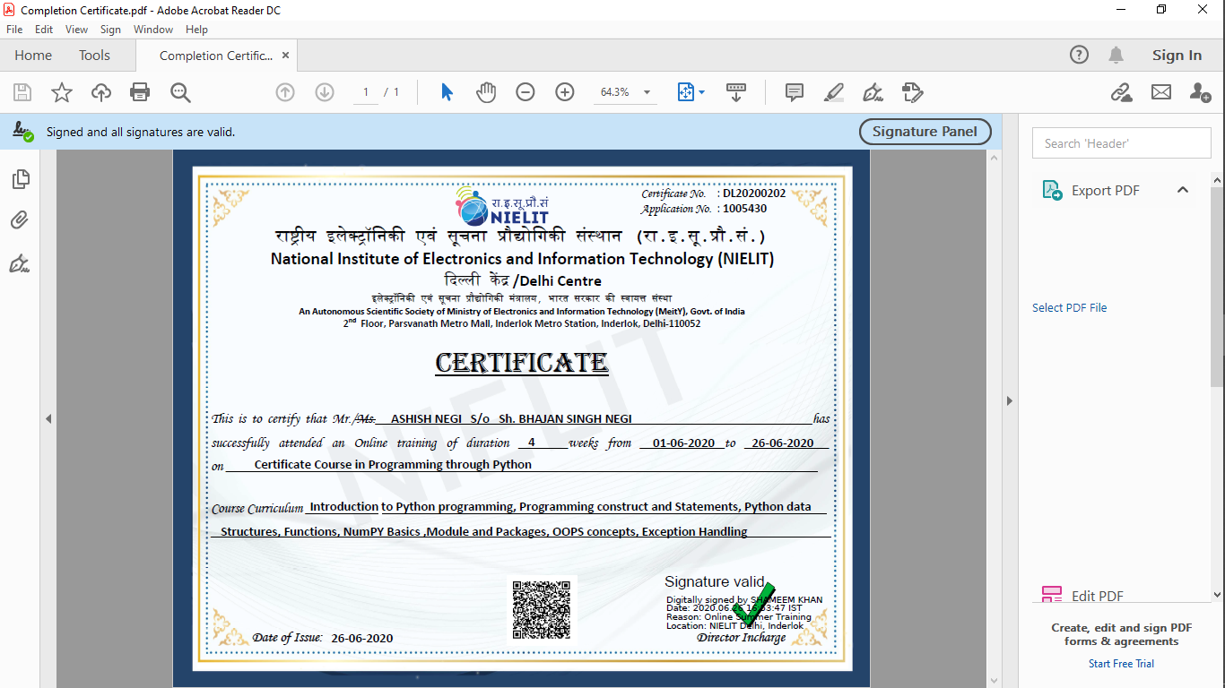

**TABLE OF CONTENTS**

|  |  |  |
| --- | --- | --- |
| **S.No** | **Topic** | **Page No.** |
| 1. | List of Tables | **8** |
| 2. | List of Figures | **9** |
| 3. | **Chapter 1: Introduction to Python** | **(10-13)** |
|  | **1.1 About Python** | **(10-13)** |
|  | **1.1.1** Introduction to Python | **10** |
|  | **1.1.2** Features of Python | **10** |
|  | **1.1.3** History and Versions | **12** |
|  | **1.1.4** Fundamental Data Types | **12** |
| 4. | **Chapter 2: Technology And Modules Used** | **(14-21)** |
|  | **2.1 About Calculator** | **14** |
|  | 2.1.1 Visual Code Studio Version | **15** |
|  | **2.2 Modules used in the project (About Tkinter)** | **15** |
|  | **2.2.1** Introduction to Tkinter | **15** |
|  | **2.2.2** Tkinter Widgets | **16** |
|  | **2.2.3** Geometry Management | **19** |
|  | **2.2.4** Math | **20** |
| 5. | **Chapter 3: Project Code** | **(22-34)** |
| 6. | **Chapter 4: Project Output (Snapshots)** | **(35-37)** |
| 7. | **Chapter 5: Future Scope and Advantages** | **38** |
| 8. | **Chapter 6: Conclusion** | **39** |
| 9. | **Chapter 7: References** | **40** |

**LIST OF TABLES**

Table 1:

Math methods used in project……………………………………………………………20

Table 2:

Math constants used in project……………………………………………..…………..21

**LIST OF FIGURES**

**Figure No. Page No.**

Fig1

Scientific calculator……….…………………………….………………..…….……14 Fig2

Visual Studio Code version………..…………………………………..………….15 Fig3

Tkinter messagebox in python……………………….…………..……..………16

Fig4

Standard Calculator using python………………………………..…….........35 Fig5

Steps to open scientific calculator using python.………….…………...35 Fig6

Scientific Calculator using python…………..………………………………….36 Fig7

Steps to Exit…………….………………………………………………………………..36 Fig8

Exit message box………………….……………………………………………….....37

**Chapter 1**

**Introduction to Python**

**1.1 About Python**

**1.1.1 Python Introduction**

Python is a general purpose, dynamic, high level, and interpreted programming language. It supports an Object Oriented programming approach to develop applications. It is simple and easy to learn and provides lots of high-level data structures.

Python is easy to learn yet powerful and versatile scripting language, which makes it attractive for Application Development.

Python’s syntax and dynamic typing with its interpreted nature make it an ideal language for scripting and rapid application development.

Python supports multiple programming patterns, including object oriented, imperative, and functional or procedural programming styles.

Python is not intended to work in a particular area such as web programming. That is why it is known as a Multipurpose Programming language because it can be used with web, enterprise, 3D, CAD, etc.

We don’t need to use data types to declare variables because it is dynamically typed so we can write a=10 to assign an integer value in an integer variable.

Python makes development and debugging fast because there is no compilation step included in Python Development, and the edit-test-debug cycle is very fast.

**1.1.2 Python Features**

1. **Easy to Learn and Use**

Python is easy to learn and use. It is a developer-friendly and high-level programming language.

1. **Expressive Language**

Python language is more expressive i.e. more understandable and readable.

1. **Interpreted Language**

Python is an interpreted language i.e. interpreter executes the code line by line at a time. This makes debugging easy and thus suitable for beginners.

1. **Cross**-**Platform Language**

Python can run equally on different platforms such as Windows, Linux, Unix etc. So, we can say that python is a portable language.

1. **Free and Open Source**

Python language is freely available along with the source-code. Therefore, it is open-source.

1. **Object-Oriented Language**

Python supports object oriented language and concepts of classes and objects come into existence.

**7) Extensible**

It implies that other languages such as C/C + + can be used to

compile the code and thus it can be used further in our python

code.

**8) Large Standard Library**

Python has a large and broad library and provides a rich set of modules and functions for rapid application development.

**9) GUI Programming Support**

Graphical User Interface can be developed using Python.

**10) Integrated**

It can be easily integrated with languages like C, C++, Java, etc.

**11) Python is a Case Sensitive Language**

Python is a case-sensitive language. This means, Variable and variable are not the same.

**1.1.3 Python History and Versions**

* Python laid its foundation in the late 1990s.
* The implementation of Python was started in December 1989 by Guido Van Rossum at CWI in Netherland.
* In February 1991, Van Rossum published the code (labeled version 0.9.0) to alt sources.
* In 1994, Python 1.0 was released with new features like: lambda, map, filter and reduce.
* Python 2.0 added new features like: list comprehension, garbage collection system.
* On December 3, 2008, Python 3.0(also called “Py3K”) was released. It was designed to rectify fundamental flaws of the language.

**1.1.4 Python Data Types**

Variables can hold values of different data types. Python is a dynamically typed language hence we need not define the type of the variable while declaring it. The interpreter implicitly binds the value with its type.

Python enables us to check the type of the variable used in the program. Python provides us the ‘type()’ function which returns the type of the variable passed.

Consider the following example to define the values of different types and check its type.

A=10

B=”Hi Python”

C=10.5

print(type(A))

print(type(B))

print(type(C))

OUTPUT

<type ‘int’>

<type ‘str’>

<type ‘float’>

Standard Data Types

A variable can hold different types of values. For example a person’s name must be stored as a string whereas its id must be stored as an integer.

Python provides various standard data types that define the storage method on each one of them. The data types defined in Python are given below.

1. Numbers
2. String
3. List
4. Tuple
5. Dictionary

**Chapter 2**

**TECHNOLOGY AND MODULES USED**

**2.1 About Calculator:**

A scientific calculator is a type of electronic calculator, usually but not always handheld, designed to calculate problems in science, engineering, and mathematics. They have completely replaced slide rules in traditional applications, and are widely used in both education and professional settings. Scientific calculators are used widely in situations that require quick access to certain mathematical functions, especially those that were once looked up in mathematical tables, such as trigonometric functions or logarithms. They are also used for calculations of very large or very small numbers, as in some aspects of astronomy, physics, and chemistry. They are very often required for math classes from the junior high school level through college, and are generally either permitted or required on many standardized tests covering math and science subjects; as a result, many are sold into educational markets to cover this demand, and some high-end models include features making it easier to translate a problem on a textbook page into calculator input, e.g. by providing a method to enter an entire problem in as it is written on the page using simple formatting tools.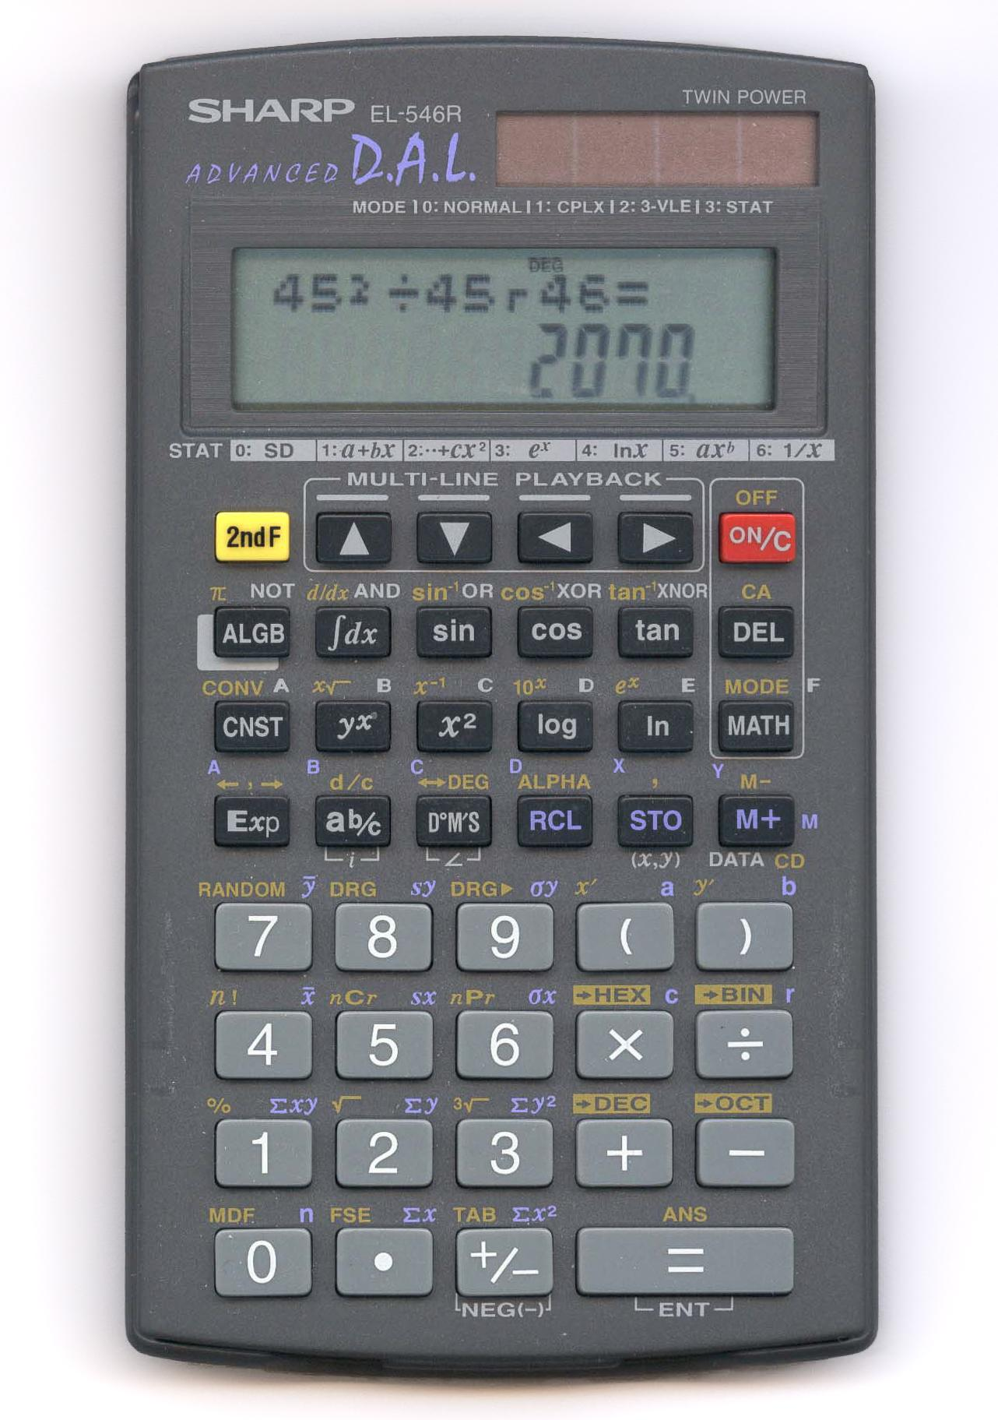

**2.1.1 Visual Code Studio Version**

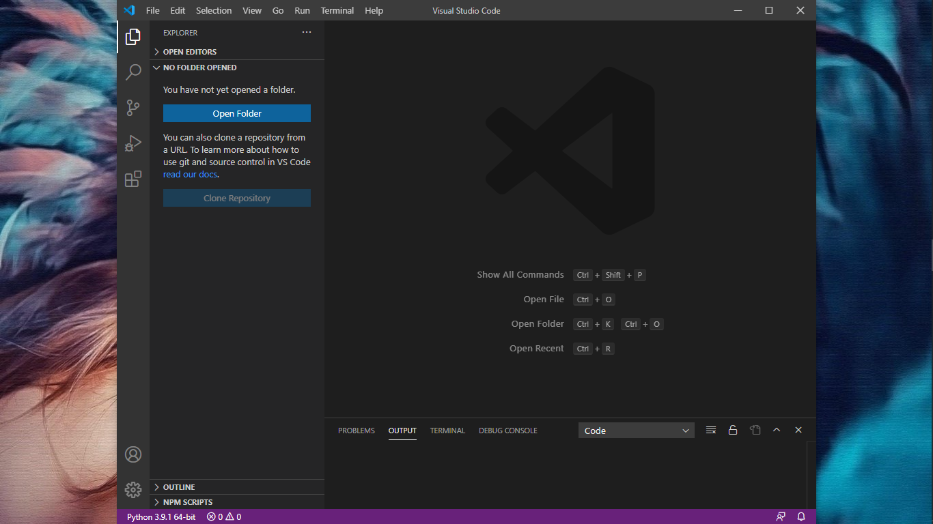

Fig6. Visual Code Studio used for the project

**2.2 Modules used in the project (About Tkinter)**

**2.2.1 Introduction to Tkinter**

Python provides various options for developing graphical user interfaces (GUIs), Tkinter being one of them.

Tkinter is the standard GUI library for Python. Python when combined with Tkinter provides a fast and easy way to create GUI applications. Tkinter provides a powerful object-oriented interface to the Tk GUI toolkit.

Creating a GUI application using Tkinter is an easy task. All you need to do is perform the following steps −

* Import the *Tkinter* module.
* Create the GUI application main window.
* Add one or more of the Tkinter widgets to the GUI application.
* Enter the main event loop to take action against event triggered by the user.

Example

#!/usr/bin/python

import Tkinter

root = Tkinter.Tk()

# Code to add widgets will go here...

root.mainloop()

This would create a following window −



**2.2.2 Tkinter Widgets**

Tkinter provides various controls, such as buttons, labels and text boxes used in a GUI application. These controls are commonly called widgets.

There are currently 15 types of widgets in Tkinter. We present these widgets as well as a brief description in the following table −

|  |  |
| --- | --- |
| **Sr.No.** | **Operator & Description** |
| 1 | [Button](https://www.tutorialspoint.com/python/tk_button.htm)  The Button widget is used to display buttons in your application. |
| 2 | [Canvas](https://www.tutorialspoint.com/python/tk_canvas.htm)  The Canvas widget is used to draw shapes, such as lines, ovals, polygons and rectangles, in your application. |
| 3 | [Checkbutton](https://www.tutorialspoint.com/python/tk_checkbutton.htm)  The Checkbutton widget is used to display a number of options as checkboxes. The user can select multiple options at a time. |
| 4 | [Entry](https://www.tutorialspoint.com/python/tk_entry.htm)  The Entry widget is used to display a single-line text field for accepting values from a user. |
| 5 | [Frame](https://www.tutorialspoint.com/python/tk_frame.htm)  The Frame widget is used as a container widget to organize other widgets. |
| 6 | [Label](https://www.tutorialspoint.com/python/tk_label.htm)  The Label widget is used to provide a single-line caption for other widgets. It can also contain images. |
| 7 | [Listbox](https://www.tutorialspoint.com/python/tk_listbox.htm)  The Listbox widget is used to provide a list of options to a user. |
| 8 | [Menubutton](https://www.tutorialspoint.com/python/tk_menubutton.htm)  The Menubutton widget is used to display menus in your application. |
| 9 | [Menu](https://www.tutorialspoint.com/python/tk_menu.htm)  The Menu widget is used to provide various commands to a user. These commands are contained inside Menubutton. |
| 10 | [Message](https://www.tutorialspoint.com/python/tk_message.htm)  The Message widget is used to display multiline text fields for accepting values from a user. |
| 11 | [Radiobutton](https://www.tutorialspoint.com/python/tk_radiobutton.htm)  The Radiobutton widget is used to display a number of options as radio buttons. The user can select only one option at a time. |
| 12 | [Scale](https://www.tutorialspoint.com/python/tk_scale.htm)  The Scale widget is used to provide a slider widget. |
| 13 | [Scrollbar](https://www.tutorialspoint.com/python/tk_scrollbar.htm)  The Scrollbar widget is used to add scrolling capability to various widgets, such as list boxes. |
| 14 | [Text](https://www.tutorialspoint.com/python/tk_text.htm)  The Text widget is used to display text in multiple lines. |
| 15 | [Toplevel](https://www.tutorialspoint.com/python/tk_toplevel.htm)  The Toplevel widget is used to provide a separate window container. |
| 16 | [Spinbox](https://www.tutorialspoint.com/python/tk_spinbox.htm)  The Spinbox widget is a variant of the standard Tkinter Entry widget, which can be used to select from a fixed number of values. |
| 17 | [PanedWindow](https://www.tutorialspoint.com/python/tk_panedwindow.htm)  A PanedWindow is a container widget that may contain any number of panes, arranged horizontally or vertically. |
| 18 | [LabelFrame](https://www.tutorialspoint.com/python/tk_labelframe.htm)  A labelframe is a simple container widget. Its primary purpose is to act as a spacer or container for complex window layouts. |
| 19 | [tkMessageBox](https://www.tutorialspoint.com/python/tk_messagebox.htm)  This module is used to display message boxes in your applications. |

**2.2.3 Geometry Management**

All Tkinter widgets have access to specific geometry management methods, which have the purpose of organizing widgets throughout the parent widget area. Tkinter exposes the following geometry manager classes: pack, grid, and place.

* [The *pack()* Method](https://www.tutorialspoint.com/python/tk_pack.htm) − This geometry manager organizes widgets in blocks before placing them in the parent widget.
* [The *grid()* Method](https://www.tutorialspoint.com/python/tk_grid.htm) − This geometry manager organizes widgets in a table-like structure in the parent widget.
* [The *place()* Method](https://www.tutorialspoint.com/python/tk_place.htm) − This geometry manager organizes widgets by placing them in a specific position in the parent widget.

**2.2.4 Math**

Python has a built-in module that you can use for mathematical tasks. The math module has a set of methods and constants.

**Math methods used in project**

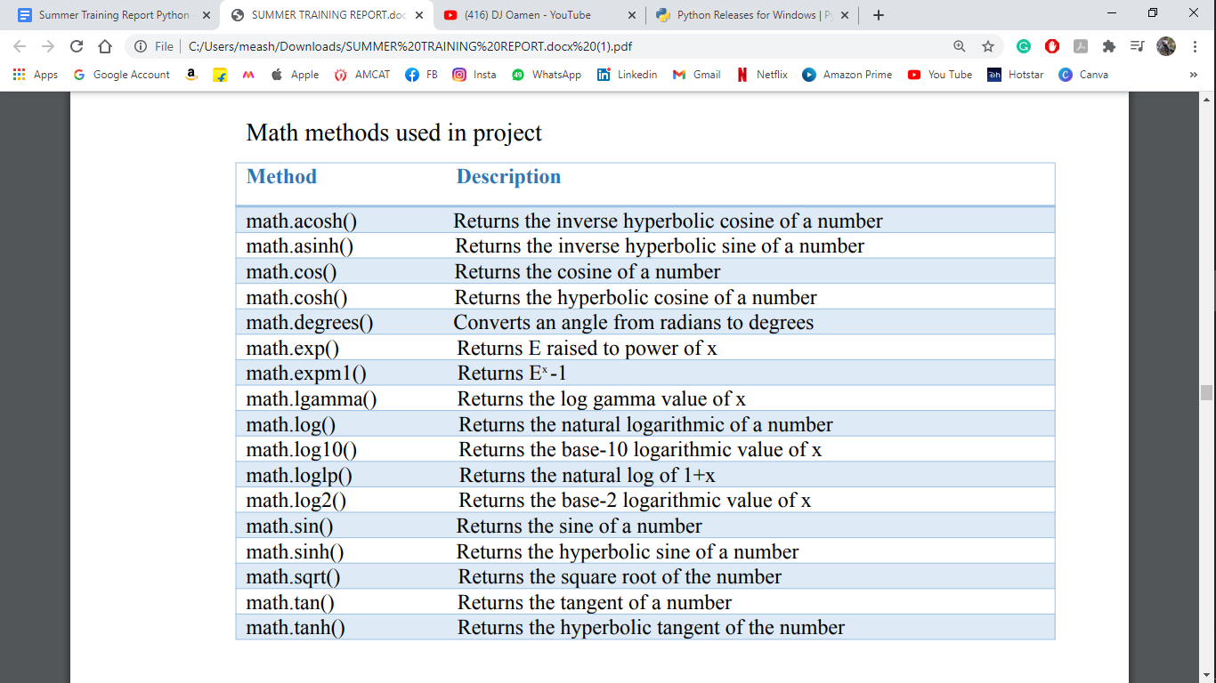

Table 1. Math methods used in project

**Math constants used in project**

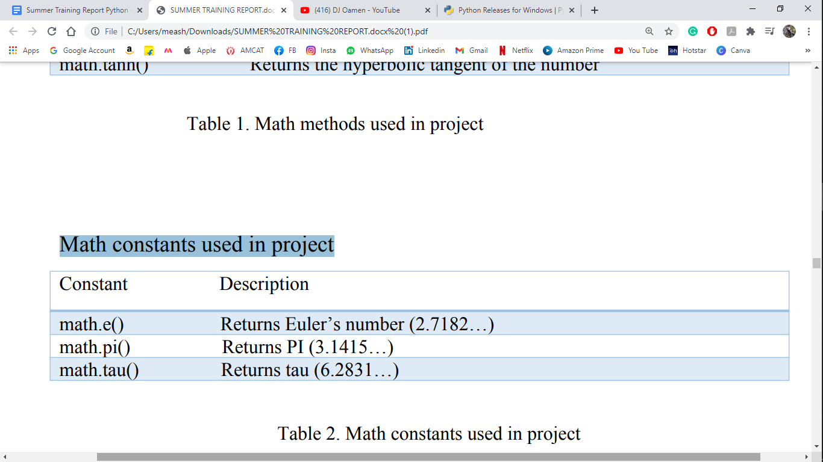

Table 2. Math constants used in project

**Chapter 3**

**Project Code**

**Scientific Calculator**

*# Scientific Calculator #*

from tkinter import *

import math

import parser

import tkinter.messagebox

root = Tk()

root.title("Scientific Calculator")

root.configure(background = 'white')

root.resizable(width=False, height=False)

root.geometry("480x568+450+90")

calc = Frame(root)

calc.grid()

*# ===================================================================================================== #*

*# Here are the Classes for all the Buttons in the Scientific Calculator.*

class Calc():

def __init__(self):

self.total=0

self.current=''

self.input_value=True

self.check_sum=False

self.op=''

self.result=False

def numberEnter(self, num):

self.result=False

firstnum=txtDisplay.get()

secondnum=str(num)

if self.input_value:

self.current = secondnum

self.input_value=False

else:

if secondnum == '.':

if secondnum in firstnum:

return

self.current = firstnum+secondnum

self.display(self.current)

def sum_of_total(self):

self.result=True

self.current=float(self.current)

if self.check_sum==True:

self.valid_function()

else:

self.total=float(txtDisplay.get())

def display(self, value):

txtDisplay.delete(0, END)

txtDisplay.insert(0, value)

def valid_function(self):

if self.op == "add":

self.total += self.current

if self.op == "sub":

self.total -= self.current

if self.op == "multi":

self.total *= self.current

if self.op == "divide":

self.total /= self.current

if self.op == "mod":

self.total %= self.current

self.input_value=True

self.check_sum=False

self.display(self.total)

def operation(self, op):

self.current = float(self.current)

if self.check_sum:

self.valid_function()

elif not self.result:

self.total=self.current

self.input_value=True

self.check_sum=True

self.op=op

self.result=False

def Clear_Entry(self):

self.result = False

self.current = "0"

self.display(0)

self.input_value=True

def All_Clear_Entry(self):

self.Clear_Entry()

self.total=0

def pi(self):

self.result = False

self.current = math.pi

self.display(self.current)

def tau(self):

self.result = False

self.current = math.tau

self.display(self.current)

def e(self):

self.result = False

self.current = math.e

self.display(self.current)

def mathPM(self):

self.result = False

self.current = -(float(txtDisplay.get()))

self.display(self.current)

def squared(self):

self.result = False

self.current = math.sqrt(float(txtDisplay.get()))

self.display(self.current)

def cos(self):

self.result = False

self.current = math.cos(math.radians(float(txtDisplay.get())))

self.display(self.current)

def cosh(self):

self.result = False

self.current = math.cosh(math.radians(float(txtDisplay.get())))

self.display(self.current)

def tan(self):

self.result = False

self.current = math.tan(math.radians(float(txtDisplay.get())))

self.display(self.current)

def tanh(self):

self.result = False

self.current = math.tanh(math.radians(float(txtDisplay.get())))

self.display(self.current)

def sin(self):

self.result = False

self.current = math.sin(math.radians(float(txtDisplay.get())))

self.display(self.current)

def sinh(self):

self.result = False

self.current = math.sinh(math.radians(float(txtDisplay.get())))

self.display(self.current)

def log(self):

self.result = False

self.current = math.log(float(txtDisplay.get()))

self.display(self.current)

def exp(self):

self.result = False

self.current = math.exp(float(txtDisplay.get()))

self.display(self.current)

def acosh(self):

self.result = False

self.current = math.acosh(float(txtDisplay.get()))

self.display(self.current)

def asinh(self):

self.result = False

self.current = math.asinh(float(txtDisplay.get()))

self.display(self.current)

def expm1(self):

self.result = False

self.current = math.expm1(float(txtDisplay.get()))

self.display(self.current)

def lgamma(self):

self.result = False

self.current = math.lgamma(float(txtDisplay.get()))

self.display(self.current)

def degrees(self):

self.result = False

self.current = math.degrees(float(txtDisplay.get()))

self.display(self.current)

def log2(self):

self.result = False

self.current = math.log2(float(txtDisplay.get()))

self.display(self.current)

def log10(self):

self.result = False

self.current = math.log10(float(txtDisplay.get()))

self.display(self.current)

def log1p(self):

self.result = False

self.current = math.log1p(float(txtDisplay.get()))

self.display(self.current)

added_value = Calc()

*# ====================================================================================================== #*

*# Here is the code for Display of Calculator.*

txtDisplay = Entry(calc, font=('Helvetica',20,'bold'),bg='black',fg='white', bd=30,

width=28,justify=RIGHT)

txtDisplay.grid(row=0,column=0, columnspan=4, pady=1)

txtDisplay.insert(0,"0")

*# ====================================================================================================== #*

*# Here is the code for NUMBER PAD in Calculator.*

numberpad = "789456123"

i=0

btn = []

for j in range(2,5):

for k in range(3):

btn.append(Button(calc, width=6, height=2, bg='white',fg='black', font=('Helvetica',20,'bold'),

bd=4,text=numberpad[i]))

btn[i].grid(row=j, column= k, pady = 1)

btn[i]["command"]=lambda x=numberpad[i]:added_value.numberEnter(x)

i+=1

*# ====================================================================================================== #*

*# Here is the code for Button of Standard Calulator.*

btnClear = Button(calc, text=chr(67),width=6, height=2,bg='black',fg='white', font=('Helvetica',20,'bold')

,bd=4, command=added_value.Clear_Entry).grid(row=1, column= 0, pady = 1)

btnAllClear = Button(calc, text=chr(67)+chr(69),width=6, height=2,bg='black',fg='white', font=('Helvetica'

,20,'bold'),bd=4,command=added_value.All_Clear_Entry).grid(row=1, column= 1, pady = 1)

btnsq = Button(calc, text="\u221A",width=6, height=2,bg='black',fg='white', font=('Helvetica',20,'bold'),

bd=4,command=added_value.squared).grid(row=1, column= 2, pady = 1)

btnAdd = Button(calc, text="+",width=6, height=2,bg='black',fg='white', font=('Helvetica',20,'bold'),

bd=4,command=lambda:added_value.operation("add")

).grid(row=1, column= 3, pady = 1)

btnSub = Button(calc, text="-",width=6, height=2,bg='black',fg='white', font=('Helvetica',20,'bold'),

bd=4,command=lambda:added_value.operation("sub")

).grid(row=2, column= 3, pady = 1)

btnMul = Button(calc, text="x",width=6, height=2,bg='black',fg='white', font=('Helvetica',20,'bold'),

bd=4,command=lambda:added_value.operation("multi")

).grid(row=3, column= 3, pady = 1)

btnDiv = Button(calc, text="/",width=6, height=2,bg='black',fg='white', font=('Helvetica',20,'bold'),

bd=4,command=lambda:added_value.operation("divide")

).grid(row=4, column= 3, pady = 1)

btnZero = Button(calc, text="0",width=6, height=2,bg='white',fg='black', font=('Helvetica',20,'bold'),

bd=4,command=lambda:added_value.numberEnter(0)

).grid(row=5, column= 0, pady = 1)

btnDot = Button(calc, text=".",width=6, height=2,bg='black',fg='white', font=('Helvetica',20,'bold'),

bd=4,command=lambda:added_value.numberEnter(".")

).grid(row=5, column= 1, pady = 1)

btnPM = Button(calc, text=chr(177),width=6, height=2,bg='black',fg='white', font=('Helvetica',20,'bold'),

bd=4,command=added_value.mathPM).grid(row=5, column= 2, pady = 1)

btnEquals = Button(calc, text="=",width=6, height=2,bg='black',fg='white', font=('Helvetica',20,'bold'),

bd=4,command=added_value.sum_of_total).grid(row=5, column= 3, pady = 1)

*# ===================================================================================================== #*

*# Here is the code for Buttons of Scientific Calulator.*

*# Here i make the rows for the Button of Scientific Calulator.*

*# ROW 1 :*

btnPi = Button(calc, text="pi",width=6, height=2,bg='white',fg='black', font=('Helvetica',20,'bold'),

bd=4,command=added_value.pi).grid(row=1, column= 4, pady = 1)

btnCos = Button(calc, text="Cos",width=6, height=2,bg='white',fg='black', font=('Helvetica',20,'bold'),

bd=4,command=added_value.cos).grid(row=1, column= 5, pady = 1)

btntan = Button(calc, text="tan",width=6, height=2,bg='white',fg='black', font=('Helvetica',20,'bold'),

bd=4,command=added_value.tan).grid(row=1, column= 6, pady = 1)

btnsin = Button(calc, text="sin",width=6, height=2,bg='white',fg='black', font=('Helvetica',20,'bold'),

bd=4,command=added_value.sin).grid(row=1, column= 7, pady = 1)

*# **************************************************************************************************** #*

*# ROW 2 :*

btn2Pi = Button(calc, text="2pi",width=6, height=2,bg='white',fg='black', font=('Helvetica',20,'bold'),

bd=4,command=added_value.tau).grid(row=2, column= 4, pady = 1)

btnCosh = Button(calc, text="Cosh",width=6, height=2,bg='white',fg='black', font=('Helvetica',20,'bold'),

bd=4,command=added_value.cosh).grid(row=2, column= 5, pady = 1)

btntanh = Button(calc, text="tanh",width=6, height=2,bg='white',fg='black', font=('Helvetica',20,'bold'),

bd=4,command=added_value.tanh).grid(row=2, column= 6, pady = 1)

btnsinh = Button(calc, text="sinh",width=6, height=2,bg='white',fg='black', font=('Helvetica',20,'bold'),

bd=4,command=added_value.sinh).grid(row=2, column= 7, pady = 1)

*#******************************************************************************************************#*

*# ROW 3 :*

btnlog = Button(calc, text="log",width=6, height=2,bg='white',fg='black', font=('Helvetica',20,'bold'),

bd=4,command=added_value.log).grid(row=3, column= 4, pady = 1)

btnExp = Button(calc, text="exp",width=6, height=2,bg='white',fg='black', font=('Helvetica',20,'bold'),

bd=4,command=added_value.exp).grid(row=3, column= 5, pady = 1)

btnMod = Button(calc, text="Mod",width=6, height=2,bg='white',fg='black', font=('Helvetica',20,'bold'),

bd=4,command=lambda:added_value.operation("mod")

).grid(row=3, column= 6, pady = 1)

btnE = Button(calc, text="e",width=6, height=2,bg='white',fg='black', font=('Helvetica',20,'bold'),

bd=4,command=added_value.e).grid(row=3, column= 7, pady = 1)

*#******************************************************************************************************#*

*# ROW 4 :*

btnlog10 = Button(calc, text="log10",width=6, height=2,bg='white',fg='black', font=('Helvetica',20,'bold')

,bd=4,command=added_value.log10).grid(row=4, column= 4, pady = 1)

btncos = Button(calc, text="log1p",width=6, height=2,bg='white',fg='black', font=('Helvetica',20,'bold'),

bd=4,command=added_value.log1p).grid(row=4, column= 5, pady = 1)

btnexpm1 = Button(calc, text="expm1",width=6, height=2,bg='white',fg='black', font=('Helvetica',20,'bold')

,bd=4,command=added_value.expm1).grid(row=4, column= 6, pady = 1)

btngamma = Button(calc, text="gamma",width=6, height=2,bg='white',fg='black', font=('Helvetica',20,'bold')

,bd=4,command=added_value.lgamma).grid(row=4, column= 7, pady = 1)

*#******************************************************************************************************#*

*# ROW 5 :*

btnlog2 = Button(calc, text="log2",width=6, height=2,bg='white',fg='black', font=('Helvetica',20,'bold'),

bd=4,command=added_value.log2).grid(row=5, column= 4, pady = 1)

btndeg = Button(calc, text="deg",width=6, height=2,bg='white',fg='black', font=('Helvetica',20,'bold'),

bd=4,command=added_value.degrees).grid(row=5, column= 5, pady = 1)

btnacosh = Button(calc, text="acosh",width=6, height=2,bg='white',fg='black', font=('Helvetica',20,'bold'),

bd=4,command=added_value.acosh).grid(row=5, column= 6, pady = 1)

btnasinh = Button(calc, text="asinh",width=6, height=2,bg='white',fg='black', font=('Helvetica',20,'bold'),

bd=4,command=added_value.asinh).grid(row=5, column= 7, pady = 1)

lblDisplay = Label(calc, text = "Scientific Calculator",font=('Helvetica',30,'bold'),

bg='black',fg='white',justify=CENTER)

lblDisplay.grid(row=0, column= 4,columnspan=4)

*# ====================================================================================================== #*

*# Here are the fucntions for ManuBar.*

def iExit():

iExit = tkinter.messagebox.askyesno("Scientific Calculator","Do you want to exit ?")

if iExit>0:

root.destroy()

return

def Scientific():

root.resizable(width=False, height=False)

root.geometry("944x568+0+0")

def Standard():

root.resizable(width=False, height=False)

root.geometry("480x568+0+0")

*# ====================================================================================================== #*

menubar = Menu(calc)

*# ManuBar 1 :*

filemenu = Menu(menubar, tearoff = 0)

menubar.add_cascade(label = 'File', menu = filemenu)

filemenu.add_command(label = "Standard", command = Standard)

filemenu.add_command(label = "Scientific", command = Scientific)

filemenu.add_separator()

filemenu.add_command(label = "Exit", command = iExit)

*# ManuBar 2 :*

editmenu = Menu(menubar, tearoff = 0)

menubar.add_cascade(label = 'Edit', menu = editmenu)

editmenu.add_command(label = "Cut")

editmenu.add_command(label = "Copy")

editmenu.add_separator()

editmenu.add_command(label = "Paste")

root.config(menu=menubar)

root.mainloop()

**Chapter 4**

**Project Outputs (Snapshots)**

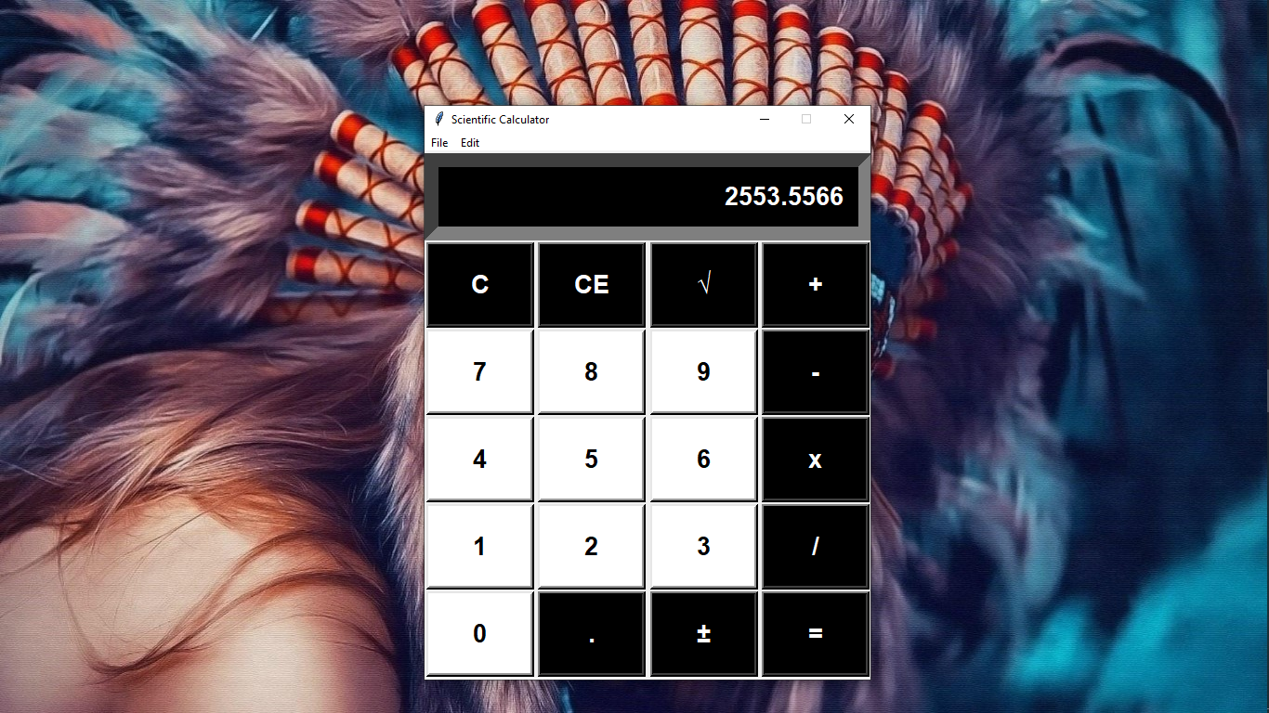

Fig4. Standard calculator using python

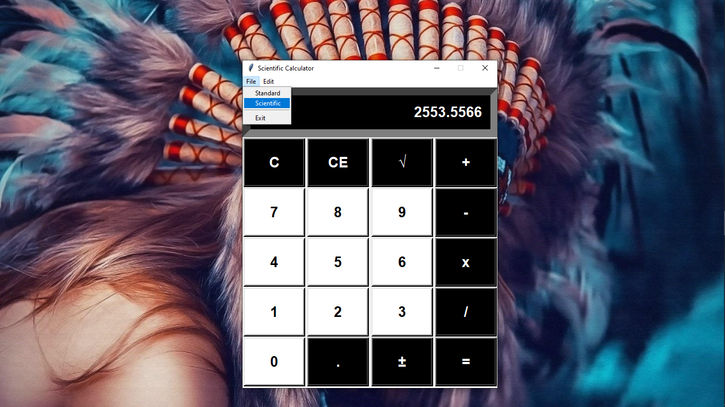

Fig5. Steps to open scientific calculator

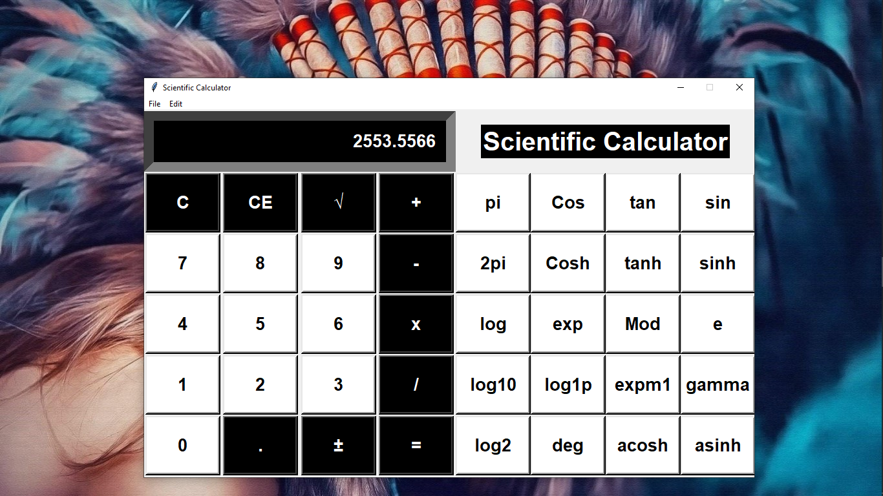

Fig6. Scientific calculator using python

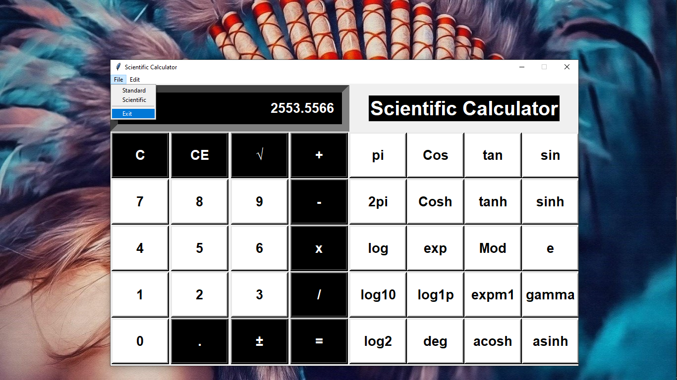

Fig7. Steps to exit

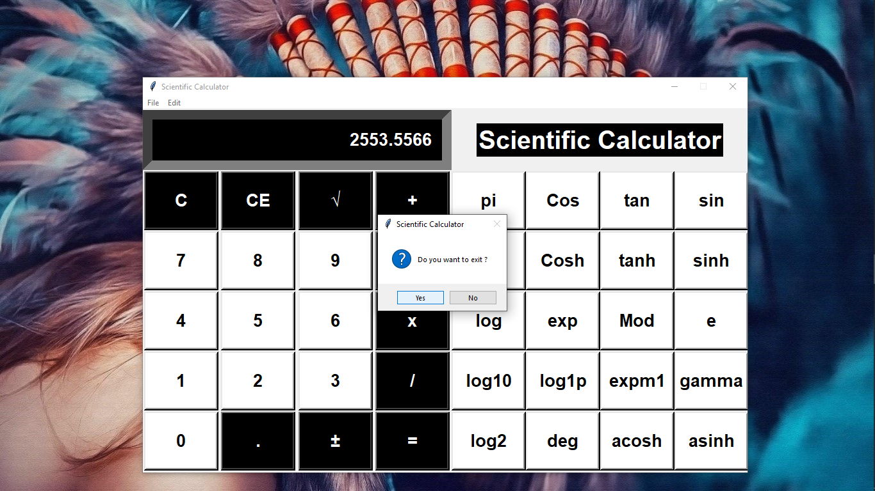

Fig8. Exit messagebox

**Chapter 5**

**Future Scope and Advantages**

**5.1 Future Scope**

Our project will be able to implement in future after making some changes and modifications as we make our project at a very low level, so the modification can be done in my project are-

* Along with manual calculations, we can modify this calculator to make unit conversions.
* With the help of technology we can also modify this scientific calculator to do currency conversions.
* We can modify this calculator to store the history of operations.

**5.2 Advantages**

* Scientific calculators can solve complicated problems quickly and in an efficient manner.
* This calculator can be used to perform all basic, necessary and scientific calculations.
* Calculator would give more accurate results than counting manually.
* It makes the calculations faster than usual.
* It will help to minimise the mathematical as well as scientific errors.

**Chapter 6**

**Conclusion**

After quite a bit of programming, the scientific calculator program is successfully created. This work has been integrated into the calculator allowing the operations to be applied to functions which use the complete set of arithmetic operations, trigonometric and logarithmic functions. A simple user interface has been created to demonstrate the calculator. The functional programming and all the mathematical operations have also been implemented.

**Chapter 7**

**References**

* **https://nielit.gov.in/delhi/**
* **https://www.python.org/**
* [**https://docs.python.org/3/library/math.html**](https://docs.python.org/3/library/math.html)
* **https://docs.python.org/3/library/tkinter.html**
* **https://codewithharry.com/videos/python-tutorial-easy-for-beginners**
* [**https://library.iated.org/view/ANDRES2015QUI**](https://library.iated.org/view/ANDRES2015QUI)